Candlewood Shores Tax District

Candlewood Shores Tax District/Water Department is pleased to offer a way for you to access your account information and pay online at your convenience.

To create a new account, go to:
https://scalzo.twa.rentmanager.com
- On the Web Access screen, click Sign up.
- On Web Access screen - click on
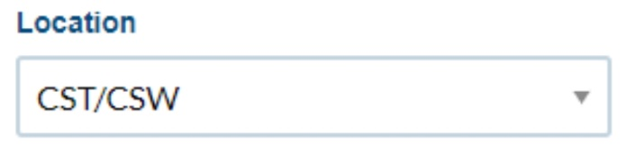

- Enter your account number: _________
- Enter your email address.
- Click “Sign up” button, then check your email to finalize your account set up.
- Repeat steps 1-3 and enter account number _________
- Enter your e-mail address.
- Click “Sign up” button, verify your password.
- Click “Save”
- This will link both tax and water accounts.
- Please note that payment type and autopay must be set-up for each account.

While logged into Web Access, click the tabs at the top of the page to:
- View your open charges
- Display your transaction history beginning 07/01/19
- Display your usage history beginning 11/01/19
- Make a payment
- Set up Autopay *Note: ACH Checking or Savings is FREE, Credit Card at 3.5% fee applies
- Change your password
- Change contact information

If you have any questions about Web Access, please do not hesitate to contact Lizz Finneran at (203) 790-6888 x403 or email: lfinneran@scalzoproperty.com.

Sincerely,

Scalzo Property Management, Inc.

